GM GLOBAL AWARENESS MONTH

UK BEACON EVENTS
SUNSET 5th MAY 07
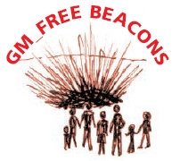
The 8th April to 8th May will be a month of global GM awareness. Countries all over the world will be using their own unique methods to remind their governments, food producers and retailers of the deep universal concerns regarding the release of GM into the general environment and food chain, as well as highlighting the catalogue of irreversible contamination incidents to date.

In the UK, the Government has given BASF the go-ahead to plant GM potato trials this year, plans that are being strongly opposed by local communities and farmers.

Around the country, beacons, which are at once symbolic of national danger and universal human hope, will be lit simultaneously at sundown on bank holiday weekend Sat 5th May.
Campaigners will be using the event to celebrate the passage of another year free of commercially grown GM crops, a luxury sadly not afforded to many countries where GM contamination is now widespread.

If eating food free of Genetically Modified Organisms, and protecting our environment from irreversible genetic pollution is something that concerns you, please join us.

Your Local Event is : -

Your Local Contact is : -

